Indian Institute of Technology, Delhi
Design Practices in Computer Science
COP290
Mathematical Model

Design and Implement a Software Package
for Engineering Drawing



January 18, 2018
Department of Computer Science and Engineering

Authors: Supervisor:
Udit Jain Prof. Subhashish Bannerjee
Shashank Goel

Abstract

We are going to design and implement a Software Package for Engineering drawing that shall be described and portrayed in a series of five steps to finely work out the design, analysis and the modelling.
The package will have the following functionalities:
- We will be able to interactively input or read from a file either
  - An isometric drawing and a 3D object model
  - Projections onto any cross section

- For a given 3D model description, the software will be able to generate projections onto any cutting plane or any cross section

- Given two or more projections, we will be able to interactively reconstruct the 3D model of the object and produce the isometric view along any view direction

In this design project, we shall work as developers and algorithm enthusiasts to understand the ways and finding different means to approach and tackle the objectives in a more well defined mathematical way. The solutions shall be presented not completely on how the human brain formulates or understands/interprets a given figure, be it 2D or 3D but in a way, that shall work out in all the cases we deal with in real life and definitely be understandable by the machine. Mathematical explanations that are more amenable to intuition are given.

Being an amateur in this field of design of software to compute projections and reconstruction of the model, it might eventually happen that the algorithm might fail in some cases or it may be proved that such an algorithm cannot exist or the model be correct but be based on certain assumptions on the construction of the object or the projections. Nevertheless, we shall work with full confidence and zeal to achieve the goal or reach to quite an end of the problem so that using our lemmas, proofs and knowledge, someday a perfect model can be implemented using a software by some other Computer Explorer.

As a matter of interest, we just wish to argue that these things can be computed by our brain so we do hope to find a solution to this problem using machine learning algorithms. Since, Machine Learning algorithms are more or less based on Mathematical matrices, with the use of computer graphics, we expect to find a start with matrices that we have dealt with further in this report.

Introduction

In the last ten years, a significant progress occurred in the area of 3D graphics. Many studies have been conducted in the field of 3D modelling, and a variety of methods that allow us to reconstruct 2D images into 3D were created. Today, 3D graphics industry creates models that can no longer be distinguished from a person in the real world or on photograph. This way of modelling is also the goal of this work; to explore options to create a photorealistic 3D model shaped from the 2D images. This article has listed and briefly described methods of converting 2D images into 3D models.

The following objectives are aimed to be covered in this paper:

- Working out a mathematical description of the problem
- Figure out how many views are necessary for reconstruction
- Figure out how many views are sufficient for reconstruction
- How to compute the projections from the 3D model?
- How to produce the isometric view using one or more projections?
- What interactions are necessary?

We shall study the direction cosines and direction ratios of a line joining two points and also discuss about the equations of lines and planes in space under different conditions, angle between two lines, two planes, a line and a plane, shortest distance between two skew lines and distance of a point from a plane. Most of the above results are obtained in vector form. Nevertheless, we shall also translate these results in the Cartesian form which, at times, presents a clearer geometric and analytic picture of the situation.

We shall further study the Vector Algebra and the 3D Transformations required to convert a given 3D Object to its projection view on any cross section and also do the same in a reverse manner i.e. converting the given projections back into the 3D Object by using matrices and their properties trying to exploit as many as possible and making them use to determine the number of different possible reconstructions possible (if any). We shall describe the assumptions while formulating the problem and prove to detail all the lemmas and theorems that are being used to define the model.

Chapter 1
Vector Algebra and 3D Transformation

1 Homogenous coordinate System
Three-dimensional scene description requires mainly using a 3D cartesian coordinate system. Points in space are uniquely determined by their three cartesian coordinates (x, y, z).
Of greater importance for computer graphics is the usage of homogeneous or projective coordinates. Ordinary points in space are given four coordinates instead of three:
1.1 Introduction
(x, y, z) ⇔ (x, y, z, w)
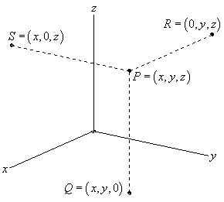
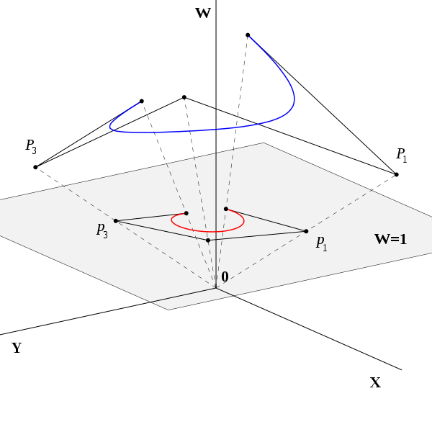

This coordinate system has wide range of applications, including computer graphics and 3D computer vision, where they allow affine transformations and projective transformations to be easily represented by a matrix
This introduces an obvious redundancy, so that the same point in 3D has infinitely many homogeneous coordinates, according to the equivalence
(x, y, z, w) ≡ (x₀, y₀, z_{0,} w₀) ⇔ α (x, y, z, w) = (x₀, y₀, z₀, w₀)
for some α ≠ 0 so that proportional 4-tuples denote the same point.
1.2 Homogenous Matrix
The concatenation of a translation with a rotation, scaling or shear requires an awkward combination of a matrix addition and a matrix multiplication. The problem can be avoided by using an alternative coordinate system for which computations are performed by 3 × 3 matrix multiplications. Since

( x’ y’ 1 ) = ( x y 1 )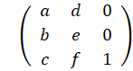

To this end a new coordinate system is defined in which the point with Cartesian coordinates (x, y) is represented by the homogeneous or projective coordinates (x, y, 1), or any multiple (rx, ry, r) with r ≠ 0.
The set of all homogeneous coordinates (x, y, w) is called the projective plane and denoted P². In order to carry out transformations using matrix computations the homogeneous coordinates (x, y, w) are represented by the row matrix (x, y, w).
The above equation implies that any planar transformation can be performed by a 3 × 3 matrix multiplication and using homogeneous coordinates. Sometimes homogeneous coordinates will be denoted by capitals (X, Y, W) in order to distinguish them from the affine coordinates (x, y).

1.3 Key Aspects
- Any point in the projective plane is represented by a triple (X, Y, Z), called the homogeneous coordinates or projective coordinates of the point, where X, Y and Z are not all 0.
- The point represented by a given set of homogeneous coordinates is unchanged if the coordinates are multiplied by a common factor.
- Conversely, two sets of homogeneous coordinates represent the same point if and only if one is obtained from the other by multiplying all the coordinates by the same non-zero constant.
- When Z is not 0 the point represented is the point (X/Z, Y/Z) in the Euclidean plane.
- When Z is 0 the point represented is a point at infinity.

Note that the triple (0, 0, 0) is omitted and does not represent any point. The origin is represented by (0, 0, 1).

1 Assumptions
- The given Object shall consist of only straight lines with well defined end points and no curved surfaces. The same shall be assumed for the Object whose projections shall be given to us

- The Views that will be given to us must be labelled with the coordinates of their corner points and be aligned with the other necessary views in a perfect orientation for correct interpretation

Basis of Assumptions:
The first assumption has excluded the possibility of curved surfaces to be present in the object. Excluding these types of surfaces might not essentially rule out the possibility of infinite number of reconstructions from the projection views but surely it would rule out many of them.
Frankly speaking, the mathematical construct used to convert the isometric view to the projection view might get complicated in some of the planes of projection as we will see in some of the examples illustrated further.
The second assumption needs to be taken into account because aligning the views and interpreting the corner points by image reading and then further naming them with some appropriate coordinates has been assumed to be out of the scope of this design project.

